

**Minutes of the Annual General Meeting of the Association for Project Management**

**Held on Monday 16th November 2020, via an online platform**

**10.30am – 11.25am**

**Chair of the meeting:** Paul Chapman, Vice President

**Present:** Approx. 100 members

**In attendance:** TheBoard Chair (Debbie Lewis), Chief Executive (Debbie Dore), Chief Financial Officer (Mark Hepworth), Company Secretary (Mike Robinson) and other APM staff were in attendance.

**Apologies for absence:** Received from President (Sue Kershaw) and Trustee Amy Morley.

**Papers provided:** The following had been made available to all attendees:

* Notice of Meeting;
* Minutes of the 2019 Annual General Meeting;
* The 2019/20 Annual Report and Accounts; and
* The 2019/20 Annual Members’ Review.

**1. Opening and the President’s Address**

The Vice President opened the meeting and welcomed those present. He outlined arrangements for the meeting and asked the Company Secretary to give the apologies for absence. He was pleased to host the meeting for APM in lieu of the President who had been unable to attend on this occasion. It was pleasing to see so many members had taken the time to log-in for the meeting which was being held online for the first time as a result of the Coronavirus pandemic. He welcomed Debbie Lewis as the new Board Chair and expressed sincere thanks to the former Chair, John McGlynn, for his sterling efforts for APM. The Association had been on a momentous journey to achieve Chartered status and John had worked to support that change and deliver the benefit it brought APM and the profession. Congratulations were also due to recently appointed Honorary Fellows and he congratulated Amanda Medler, Prof. Andrew Davies and John Algar on their achievement.

The purpose of the meeting was to reflect on the 2019/20 financial year but it was also right to recognise the efforts of the CEO and her team in making the changes necessary to continue delivery during the Coronavirus pandemic. The efforts to move delivery online had been significant and successful. The year had been difficult and high levels of tenacity and resilience had been seen.

APM was grateful to Alistair Godbold who had finished his term of office as a trustee and given years of dedicated service; he would continue to support APM as representative at the International Association for Project Management.

Heartfelt appreciation was given to the hundreds of volunteers in branches, SIGs and other valuable roles. Through their support and contributions APM had seen real progress and this reflected the Association at its best.

**2. Minutes of the Annual General Meeting held on 18th November 2019**

The minutes of the previous Annual General meeting were approved as a correct record. There were no matters arising raised.

**3. Receipt of the Annual Accounts of the Association for Project Management for the Year Ended 31st March 2020, the Report of the Trustees and the Auditors’ Report**

The Vice President invited the Chair of the Board, the Chief Executive and the Chief Finance Officer to present on the achievements of the year, the annual report and accounts for 2018/19, and APM’s forward plans.

**The Board Chair** opened the presentation and outlined the current strategy, vision, mission and objectives. 2020 had of course been unusual in the extreme and she outlined the steps taken to deal with the fallout from the pandemic. There had been a priority on supporting staff and stakeholders and to make sure core value was delivered. APM had used scenario planning, extra forecasting and additional Board meetings to provide the governance necessary to react. Close attention had been paid to risks and new digital ways of working.

Updates were given on three projects from 2019/20:

* On project data analytics, an advisory group up had been established and was now creating content.
* Climate change had seen action with a new statement agreed and action plan created. Embedding this topic into the new competence framework was being considered.
* There had been some work on the APM Brand with the creation of a new brand done story and attributes. There would be further work on a possible new name and the visual brand.

The Chair set out how the trustees had ensured APM’s core purpose and public benefit had been delivered. Trustees would continue to support APM through the pandemic and look to further build the membership proposition and would lead on an update to the corporate strategy. She was keen to ensure the Board was as good as it could be and for it to both supportive and challenging. The Association was very much looking forward to 50th anniversary in May 2022.

**The Chief Executive** presented on achievements during the 2019/20 year. This had largely been prior to the pandemic and incredibly successful overall. Highlights included being in the Times Top 100 best companies to work for, winning the Association of the Year Award, publishing first class research like *The Golden Thread* and increases in membership. APM had achieved over 20,000 qualifications, 1000 Chartered Project Professionals (ChPPs), delivered the new Body of Knowledge (BoK) and over 100 school and university events. Many projects had also been delivered and these included the new community platform, an easier renewal process, moving to a new digital supplier, aligning qualifications to the new BoK, a new IT qualifications platform and new open online course options.

There had also been a focus on external affairs and research work. A lot had been achieved to develop APM’s voice with more public commentary made. The high level of research creation and dissemination was also building the profile of APM and the profession. Key research topics were outlined.

There had been significant investment in digital services during the year. For example, the new online qualifications platform had been brought forward due to the arrival of the pandemic. To date, over 6500 qualifications had been delivered on the new platform. This had been critical to APM’s sustainability and she and the team were rightly very proud of this achievement.

The CEO closed by expressing her thanks to APM’s volunteers. They had really stepped up and assisted during the pandemic to deliver webinars, articles, blogs and highly valued support.

**The Chief Financial Officer** presented the financial highlights from the 2019/20 annual report and accounts. He confirmed that the report of the independent external auditor was to issue a full, unqualified audit opinion.

For 2019/20, there had been a £300k excess over budget to deliver a net operating surplus for the year. Investments had fallen towards the year-end due to the impact of the pandemic but had since recovered. Income had increased across most areas of activity with qualifications in particular seeing an increase of 14.2%. Events revenue had fallen due to cancellations because of the pandemic but had been very well attended beforehand. Membership had shown strong growth during the year at plus 11% with increases in most grades. APM had also been successful in attracting more apprenticeships.

The impact on performance from Coronavirus remained a focus but the Board and auditor had been confident APM remained a going concern. APM had benefited from robust planning, increased forecasting and a solid level of reserves. Membership numbers had held up well and applications for ChPP were strong. Online delivery of qualifications was helping recover lost examinations income. There had been rigorous cost controls with some projects deferred. The value of investments had recovered well. There had been a reduction in reserves and staff numbers had also been impacted.

The Vice-President thanked the team for their informative presentation which had provided encouraging news. The meeting therefore received and noted the annual report and accounts for 2019/20 and the report of the auditor.

**4. The APM Board Election**

The Company Secretary reported the results of the 2020 Board election. APM had seen another strong field of candidates and had achieved a new record turnout of 26.6%; a one third increase in votes over last year’s record. This was considered to be in the top 10-15% for similar membership organisations.

Under the Charter and Regulations, the election was undertaken as a poll vote with the ballot delivering proxies to the AGM. The three candidates receiving the highest votes were therefore noted and affirmed. Karen Whelan, Jon Broome and Charles Mills were elected to the Board for a period of three years. The Company Secretary congratulated the new Trustees and thanked all those who participated. The full results were as follows:

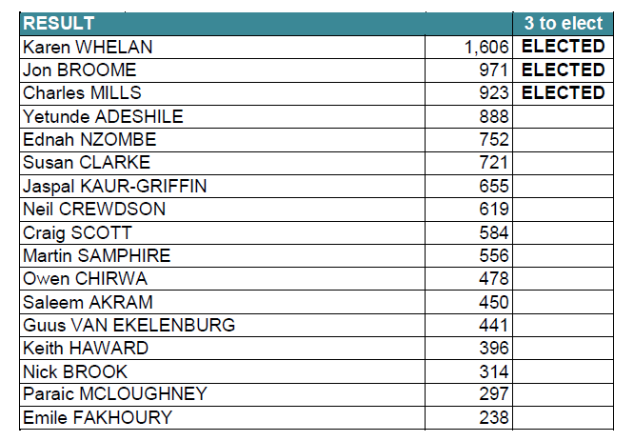

**5. Members’ Questions**

The Vice President noted that on this occasion no members’ written questions had been submitted in advance of the meeting.

However, questions from the floor were invited and taken as follows:

* The CFO explained that the heading ‘subscription costs’ in the accounts was a broad category and included a wide range of support office costs, including marketing spend. Detail was set out in the full annual report and accounts and he was happy to receive a separate query on the matter.
* Several members queried the possibility of a reduction or freeze in membership fees in light of the continuing pandemic. The CEO recognised the feelings expressed and explained that the Board would shortly be looking at membership fees and carefully consider the options. A communication on the decision would be issued.
* In respect of a possible revised name for APM, the Company Secretary explained that if a new identity was agreed this would most likely be adopted as a trading name. The name of the corporation would therefore remain the same and there would be no need for a vote to change the Royal Charter. The Board Chair explained that branding work had been deprioritised during the initial lockdown period. The name of APM would be considered very carefully and in the light of careful stakeholder consultation. The possibility of there being no change to the name remained. All the current options had compromises.
* A query was raised on investment fund management fees and whether they represented value for money. The CFO explained that investments had fallen less than the overall market due to APM’s risk profile and the active management undertaken. Long-term returns were good and performance was closely monitored. The Board Chair highlighted it was important to recognise where APM did not have specialist skills and where it was necessary to get best in class advice. This helped maximise the return on charitable funds.
* The Company Secretary confirmed that all full and fellow members had received notification of the opportunity to submit written questions in advance.

**6. Closing Remarks**

The Vice President recalled a comment from Dr Martin Barnes that, at its heart, project management was about people getting things done. This was particularly relevant in the context of the difficult year all had faced due to the Coronavirus pandemic and many had come to realise the benefit of sound delivery and well-run projects at this challenging time. He thanked the team for their organisation of the event and members for their attendance and helpful contributions.

The Chair of the Board also thanked members for attending and expressed her thanks to the Board and the Executive for their work over the last 12 months. She recorded thanks to former trustees John McGlynn, Alistair Godbold and Paul Chapman who had left the Board during the year for their service to APM. The meeting was also grateful to the Vice President for stepping in and chairing the meeting.

The Chair was delighted to welcome the newly elected trustees and looked forward to working with them. Despite the pandemic, 2020 had been a successful year with much to celebrate. APM could emerge stronger and bolder and would be active in taking the profession forward.

The meeting closed at 11.25am.